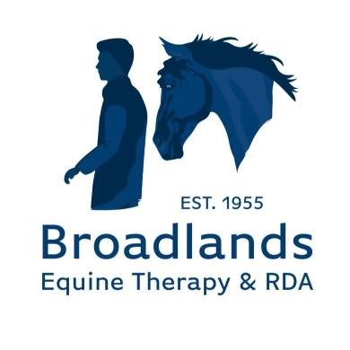

**Broadlands Group Riding for the Disabled**

# Client Enrolment Policy (Group)

1. **Purpose of this Policy**

This policy sets out the criteria for client admission to Broadlands RDA programmes where the client is part of a group enrolment.

Broadlands Group RDA are moving to a more formal commitment for sessions commissioned by our clients and/or their carers so that:

* + - We maximise the availability of all sessions for existing and new clients and avoid last minute no-shows.
    - Clients and Broadlands RDA enter into a commitment, one to receive services, and the other to make those services available reliably and regularly.
    - We can have certainty of income from contributions/donations.

This policy sets out how this will work.

1. **Client Eligibility Criteria**

Broadlands RDA welcomes clients who meet the following criteria:

* 1. Minimum age 5 years for RDA (Hippotherapy 18 months)
  2. Maximum age on a weekend 16 years
  3. Maximum weight (riding) 70kg/10.5 Stone
  4. Live/reside within a 30-mile radius of Broadlands RDA
  5. Undergo and pass a qualification assessment by Broadlands RDA coaches.

1. **Client Commitment**

Our sessions are run weekly throughout the year, with the exception of a two-week break aligning with the Hampshire County Council school Christmas break. Where the client is part of a school group, it is assumed that sessions will not be attended during the Hampshire County Council school holidays. Sessions will continue to run on school inset days.

Clients wishing to enrol, or their carers, must complete an application form. This holds key contact and health information and will be used by Broadlands RDA coaches to undertake a client risk assessment to inform the most suitable and safe client activity. Once an application has been received, we will contact the client and arrange for an introduction/assessment meeting at the stables with an RDA accredited Coach.

Clients agree to the contribution/donation structure set out in section 4.

If the client wishes to terminate their scheduled group sessions, notice of 1 term must be provided to Broadlands RDA via email to office@broadlandsgrouprda.org.uk.

1. **Contributions/Donations for sessions**

It costs c£120,000 annually to feed, house and keep fit our ponies and equipment. The costs reflect the running costs of the centre, spread across the services we can supply. No profit is included.

As a charity we ask for a contribution/donation towards this of £30 per session, payable by groups termly in advance.

No refunds for session cancellations or no shows by the client will be given.

Failure to make payment for the scheduled sessions may result in future session being cancelled. Repeated failure to pay may result in the termination of all scheduled sessions. See section 5.

1. **Broadlands RDA commitment**

We undertake to schedule weekly sessions in alignment with the Hampshire County Council school term of up to 30 minutes to each client each year, with sessions only cancelled under the rarest conditions, usually severe adverse weather or horse illness.

Broadlands RDA reserves the right to terminate the scheduled sessions if it believes a client no longer meets the qualifying criteria. Broadlands RDA will provide a 1-week warning followed by notice of 1 week to the client of its intention to terminate the scheduled sessions, including the reason why they believe the client no longer qualifies.

Clients have the right to appeal the decision to terminate their sessions. Appeals should be made via email to office@broadlandsgrouprda.org.uk and must be submitted within 1 week of receipt of the notification to terminate.

Appeals will be reviewed by the Board of Trustees, whose decision will be final. The client will not be eligible to participate in sessions whilst the appeal is ongoing.

**6. Privacy and Data Protection**

All personal data collected in relation to client enrolment will be treated according to our Privacy

Notice and Data Protection Policy. Copies of these policies can be found at https://www.broadlandsgrouprda.org.uk/policies